**Servlet implémentation devoir 2**

**Code :**

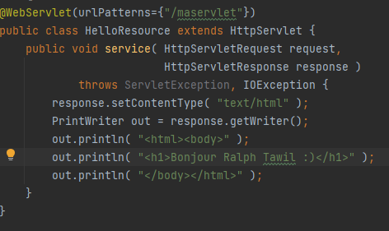

**Output :**

**Code :**

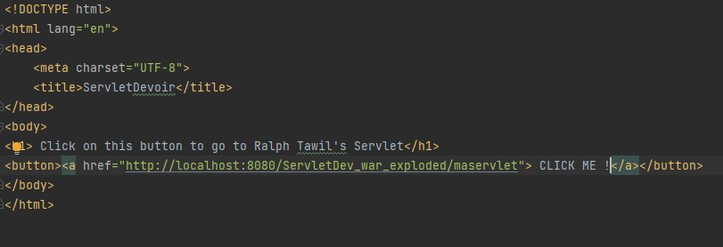

**Output :**

**After clicking the button :**

